DSA0601- Data handling and visualization
Name: Prasanna.M
Reg No: 1925260244
Question 1
Create a line chart to visualize the monthly sales. Label the axes and title the chart appropriately.
R Code:
library(ggplot2)

sales_data <- data.frame(
Month = factor(c("January", "February", "March", "April", "May"),
levels = c("January", "February", "March", "April", "May")),
Sales = c(15000, 18000, 22000, 20000, 23000)
)

p1 <- ggplot(sales_data, aes(x = Month, y = Sales, group = 1)) +
geom_line(color = "black", linewidth = 1) +
geom_point(color = "black", size = 3) +
geom_text(aes(label = Sales), vjust = -1, size = 4) +
labs(title = "Monthly Sales (January to May)",
x = "Month",
y = "Sales (in $)") +
scale_y_continuous(limits = c(0, 26000)) +
theme_bw() +
theme(plot.title = element_text(hjust = 0.5, face = "bold"))

print(p1)
ggsave("q1_output.png", plot = p1, width = 8, height = 5, dpi = 150)
Output:
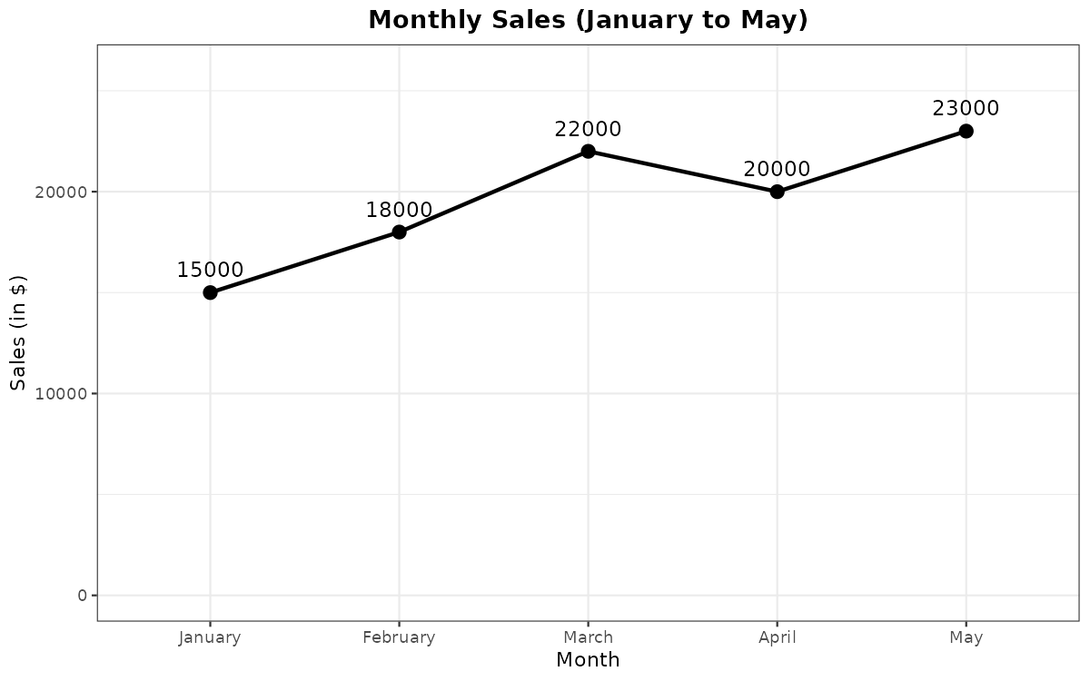
Question 2
Generate a bar chart to display the top-selling products for the year. Label the chart elements.
R Code:
library(ggplot2)

product_data <- data.frame(
Product = c("Laptop", "Smartphone", "Tablet", "Headphones", "Smartwatch"),
Sales = c(48000, 61000, 27000, 19000, 15000)
)

sorted_products <- product_data$Product[order(-product_data$Sales)]
product_data$Product <- factor(product_data$Product, levels = sorted_products)

p2 <- ggplot(product_data, aes(x = Product, y = Sales)) +
geom_col(fill = "grey60", color = "black", width = 0.6) +
geom_text(aes(label = Sales), vjust = -0.5, size = 4) +
labs(title = "Top-Selling Products for the Year",
x = "Product",
y = "Total Sales (in $)") +
scale_y_continuous(limits = c(0, 70000)) +
theme_bw() +
theme(plot.title = element_text(hjust = 0.5, face = "bold"))

print(p2)
ggsave("q2_output.png", plot = p2, width = 8, height = 5, dpi = 150)
Output:
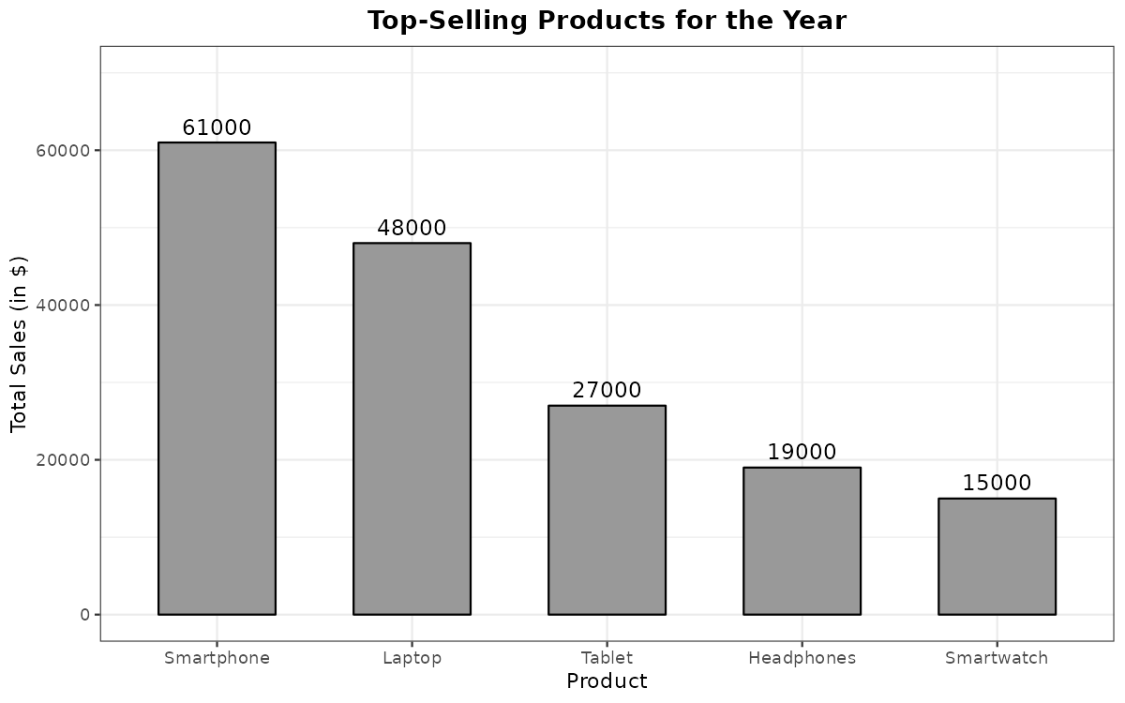
Question 3
Develop a scatter plot to explore the relationship between advertising budget and monthly sales. Explain the insights drawn from the scatter plot.
R Code:
library(ggplot2)

ad_data <- data.frame(
Month = c("January", "February", "March", "April", "May"),
Budget = c(2000, 2500, 3200, 2900, 3500),
Sales = c(15000, 18000, 22000, 20000, 23000)
)

r <- cor(ad_data$Budget, ad_data$Sales)
model <- lm(Sales ~ Budget, data = ad_data)
cat("Correlation coefficient (r):", round(r, 4), "\n")
cat("R-squared:", round(summary(model)$r.squared, 4), "\n")
print(coef(model))

p3 <- ggplot(ad_data, aes(x = Budget, y = Sales)) +
geom_point(color = "black", size = 3) +
geom_smooth(method = "lm", se = FALSE, color = "black",
linetype = "dashed") +
geom_text(aes(label = Month), hjust = 1, nudge_x = -80,
nudge_y = 350, size = 3.5) +
scale_x_continuous(limits = c(1600, 3700)) +
labs(title = "Advertising Budget vs Monthly Sales",
x = "Advertising Budget (in $)",
y = "Monthly Sales (in $)") +
theme_bw() +
theme(plot.title = element_text(hjust = 0.5, face = "bold"))

print(p3)
ggsave("q3_output.png", plot = p3, width = 8, height = 5, dpi = 150)
Console Output:
Correlation coefficient (r): 0.9971
R-squared: 0.9942
(Intercept) Budget
4280.979827 5.432277
Output:
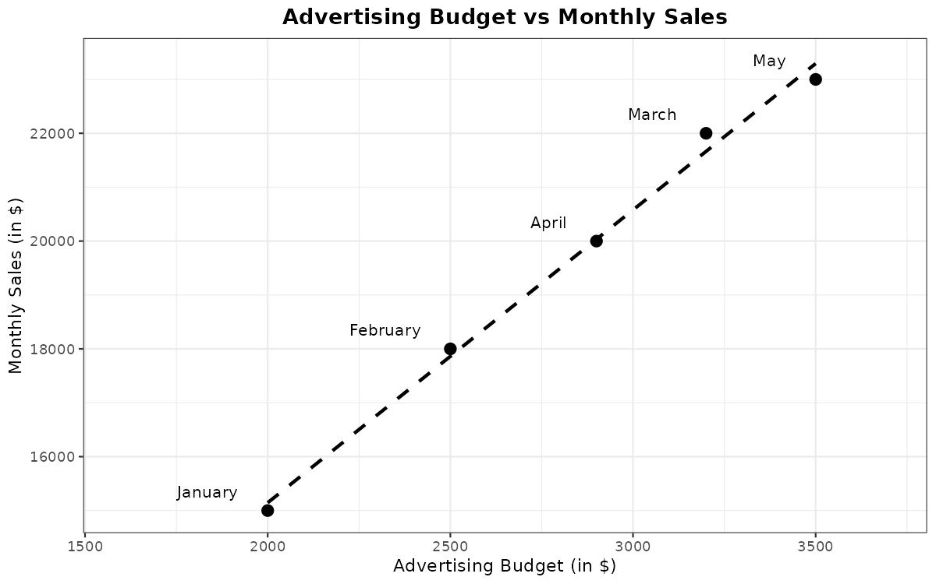
Question 4
Build an interactive dashboard combining the line chart and bar chart to allow users to explore sales data interactively.
R Code:
library(shiny)
library(plotly)

months <- c("January", "February", "March", "April", "May")

sales_data <- data.frame(
Month = months,
Sales = c(15000, 18000, 22000, 20000, 23000),
stringsAsFactors = FALSE
)

product_data <- data.frame(
Product = c("Smartphone", "Laptop", "Tablet", "Headphones", "Smartwatch"),
Sales = c(61000, 48000, 27000, 19000, 15000),
stringsAsFactors = FALSE
)

ui <- fluidPage(
titlePanel("Sales Dashboard"),
sidebarLayout(
sidebarPanel(
checkboxGroupInput("months", "Select months (line chart):",
choices = months, selected = months),
sliderInput("min_sales", "Minimum product sales in $ (bar chart):",
min = 0, max = 60000, value = 0, step = 5000)
),
mainPanel(
plotlyOutput("line_chart", height = "320px"),
plotlyOutput("bar_chart", height = "320px")
)
)
)

server <- function(input, output) {

filtered_sales <- reactive({
sales_data[sales_data$Month %in% input$months, ]
})

filtered_products <- reactive({
product_data[product_data$Sales >= input$min_sales, ]
})

output$line_chart <- renderPlotly({
df <- filtered_sales()
plot_ly(df, x = ~Month, y = ~Sales, type = "scatter",
mode = "lines+markers",
line = list(color = "black"),
marker = list(color = "black", size = 8)) %>%
layout(title = "Monthly Sales",
xaxis = list(title = "Month",
categoryorder = "array",
categoryarray = months),
yaxis = list(title = "Sales (in $)", rangemode = "tozero"))
})

output$bar_chart <- renderPlotly({
df <- filtered_products()
df <- df[order(-df$Sales), ]
plot_ly(df, x = ~Product, y = ~Sales, type = "bar",
marker = list(color = "grey",
line = list(color = "black", width = 1))) %>%
layout(title = "Top-Selling Products for the Year",
xaxis = list(title = "Product",
categoryorder = "array",
categoryarray = df$Product),
yaxis = list(title = "Total Sales (in $)"))
})
}

shinyApp(ui = ui, server = server)
Output:


